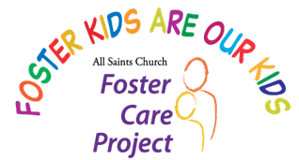

20th Anniversary

Sports Funding Program Application

To be Completed by DCFS Pasadena/Glendale CSW Only

Please review guidelines before completing this form. You may email the form and any questions to fcp.sportsfunding@gmail.com

Nominee Name (First, last, and

middle *initial if membership fees required;*

*first name and last initial otherwise*.)

Age  Youth Status (current, former, transition age foster youth)

Participating Sport(s)

And Items Needed

Items (include online link if available) Amount

$

Amounts Requested

Itemized. Add Extra

Page if Needed

**Additional Information**

Name & Address (or website) of Team or Other Entity (*required*)

Address (street, city, state, ZIP code)

Have Other Resources, Such as DCFS Been Explored? **Yes No**

If DCFS Funds Have Not Been Explored, Will They Be? **Yes No**

If Not, Why Not?

Did Other Resources Cover Any Costs? **Yes No**

If Yes, How Much?

Application Completed by (Name & DCFS Title)

Phone Number Email

Signature

FCP 4/1824